Evaluation Board used for SX12XX library

1. Introduction

To test the example programs in the SX12XX library I developed a small Arduino Pro Mini based board that could be used for general purpose LoRa testing, sensor and tracking applications. The ‘Easy Pro Mini’ board uses a minimum number of parts and can be easily built in a basic form, using just a few standard wired components and pin headers. The board can readily be switched between lora module types. The library is here;

https://github.com/StuartsProjects/SX12XX-LoRa

You can plug in a range of Stuartsprojects breadboard friendly boards and these are available for most of the different lora modules. The parts needed to build a basic Easy Pro Mini board are shown below, you need to supply your own Arduino Pro Mini and lora module;
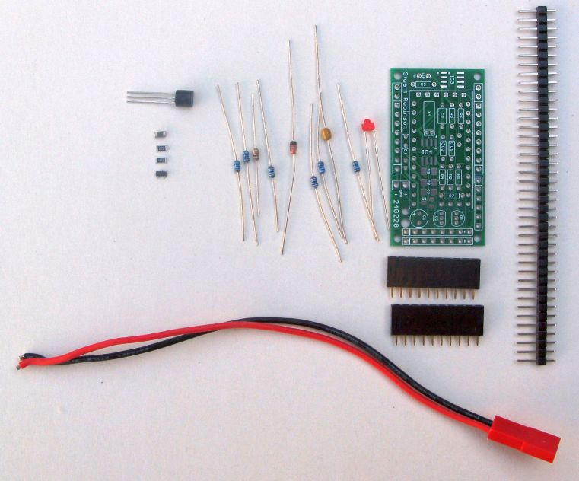

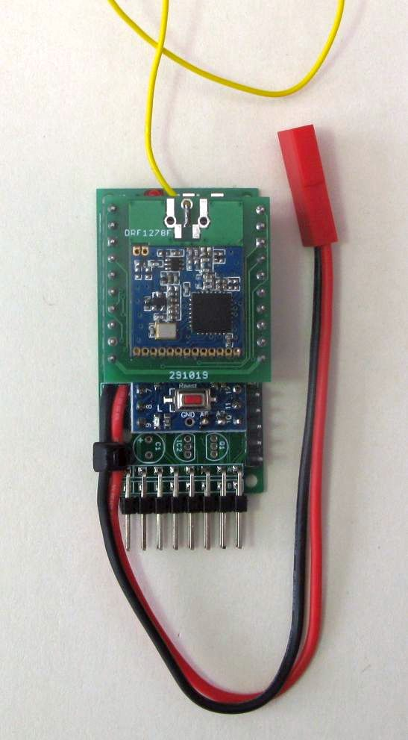
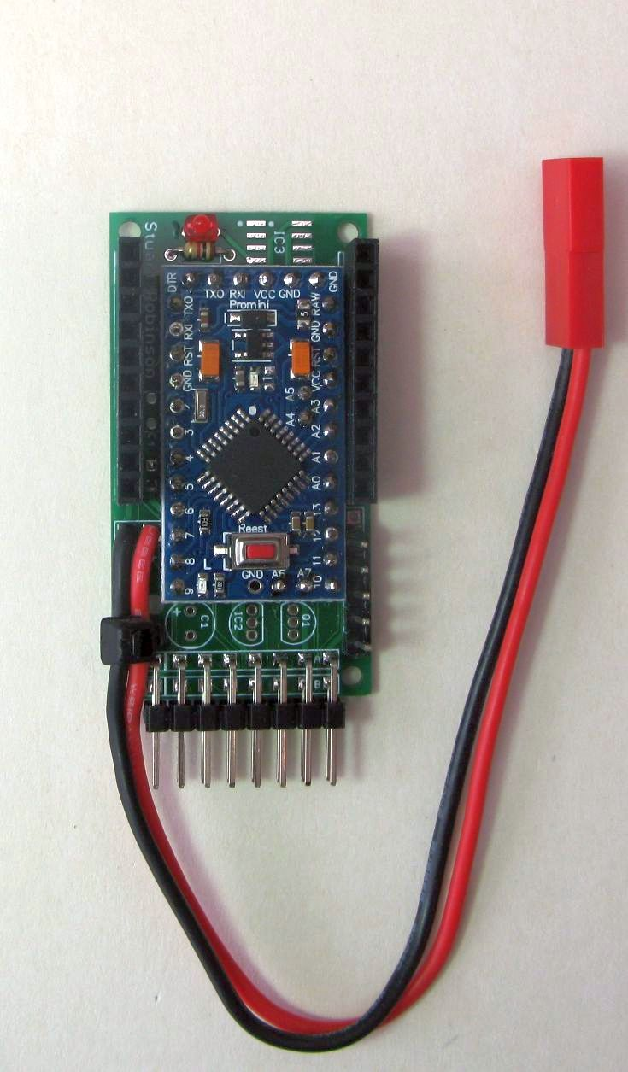

There are 10 way 0.1” header sockets on the long edges of the PCB and 2 x 8 way pin connectors on the bottom edge of the PCB. The Pro Mini used is an 3.3V 8Mhz type advertised at low cost on sites such as eBay. These Pro Minis have on the RAW pin power input a reverse protection diode and a fuse. The expansion connectors on the end provide pins for connecting devices such as GPS, analogue devices, I2C sensors or displays, switches etc.;

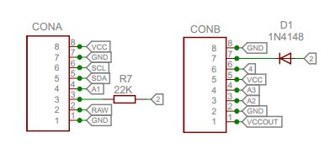

The pinouts available on the socket are;

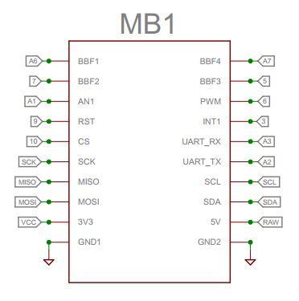

The completed Easy Pro Mini can be easily swapped between most of the current lora devices by soldering the lora module onto the appropriate PCB and plugging it in. Shown below (left to right) are assembled plug in modules for SX1276 (Dorji), SX1272 (Dorji), RFM98 (Hope), SX1262 (NiceRF), SX1276/8 (Dorji) and SX1280 (NiceRF).

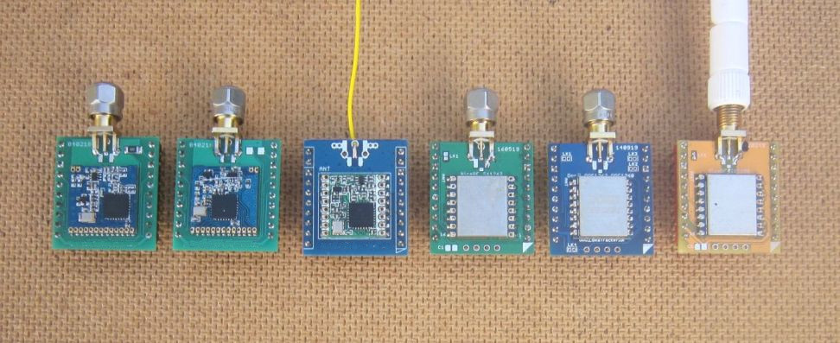

The base build (described below) is all that most people will want but you can add other parts to the board;

1. Surface mount parts to allow an external device, such as a GPS, to be powered off thus saving battery power. These parts are supplied wit the kit

2. A DS18B20 temperature sensor. Parts not supplied with the kit.

3. A PCF8563 real time clock that can be used to wakeup the board from sleep using RTC alarm functions. Parts not suppled with the kit.

4. A 2kbyte or 8kbyte FRAM for data backup that survives power downs. Part not supplied with the kit.

2. Typical applications

One of the example programs is an application that reads a BME280 sensor and transmits the values to a remote receiver which then shows the sensor values on an OLED display. The two boards used the test the sensor application are shown below, with the LoRa modules plugged in;
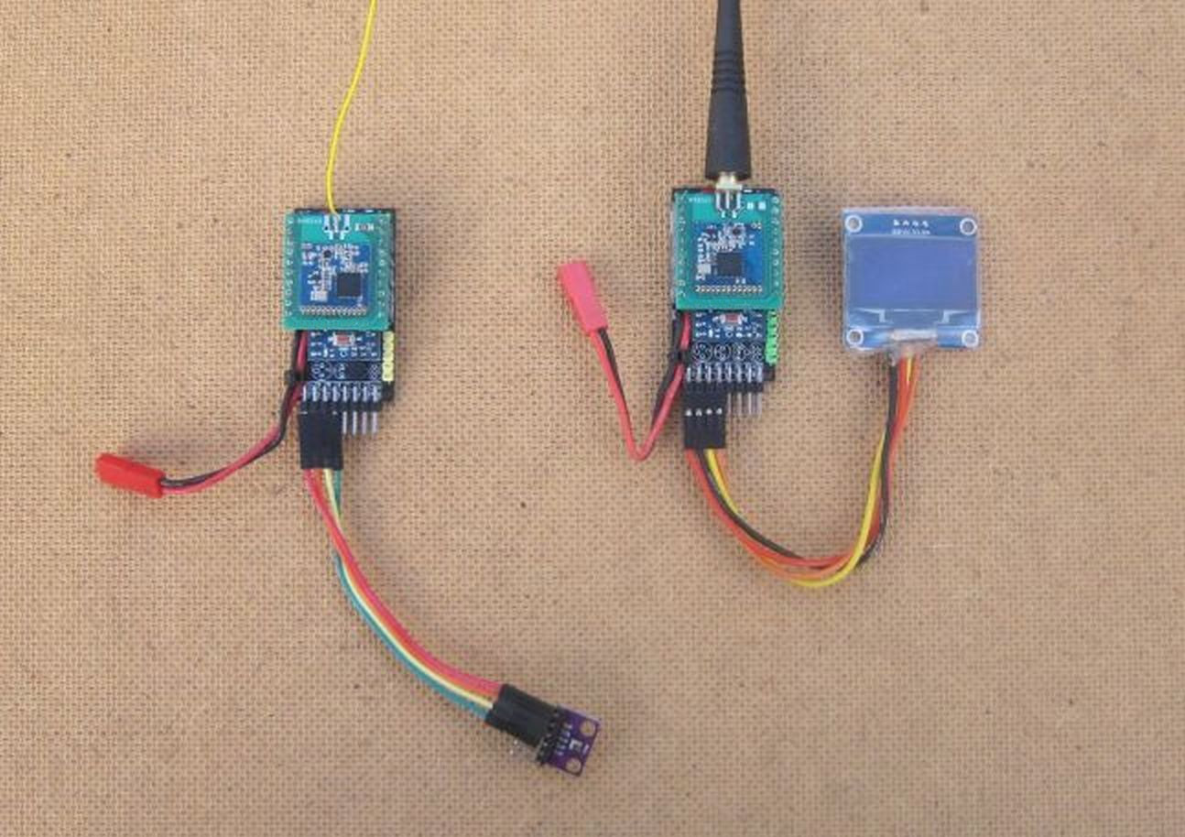

Another of the example programs is a demonstration of remote control basics, switching traffic light LEDs on and off via a lora link.
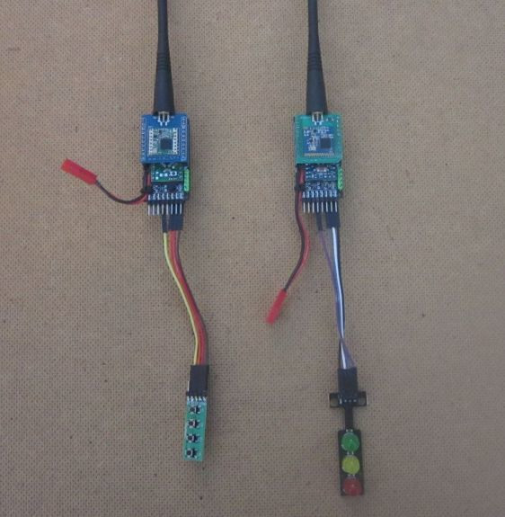

There is also an example programs for a GPS tracker, this reads a GPS and uses lora to transmit the location of the tracker to a remote receiver, the receiver shown has its own GPS and is able to calculate the distance to and direction of the remote transmitter. See below;

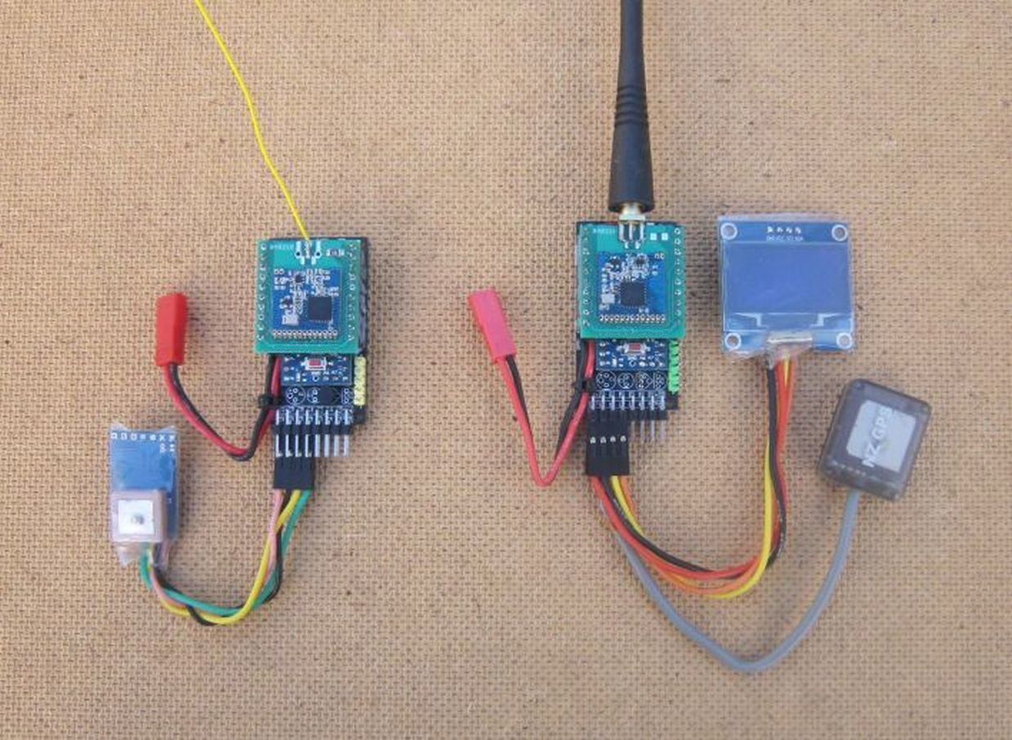

The GPS tracker transmitter and receiver are quite small and suitable for portable operations such a trackers for ‘lost’ radio controlled models and similar. The advantage of using the breadboard friendly modules is that its easy to change the board between the range of lora modules and makes testing easier too.
You could design smaller boards for GPS trackers and similar, but this inevitably involves using surface mount component which results in far more complex assembly. The Easy Pro Mini board needs only minimal soldering skills to assemble and is very low cost too.

The example programs for the applications shown above should be usable with other Arduinos, but remember that the LoRa modules are 3.3V logic devices, so do not connect directly to 5V Arduinos, some form of logic level conversion will be needed.

3. Base board build part 1

Read through all of these build instructions before you start !
…… adding components and building the board. There are options in the build that you need to understand and you will only know which components to fit if you have read through all the build instructions. Once the Pro Mini is soldered in place you may not be able to fit the parts for some of the build options.
When reading the instructions, you will notice that compromises are made with the way that the pins on the ATmega are used. The pins available on the ATmega328P are limited in number so there are inevitable compromises in how the limited pins are used and shared.
The build instructions will describe each component added in turn and options for whether the component needs to be fitted.

Starting with the main PCB;

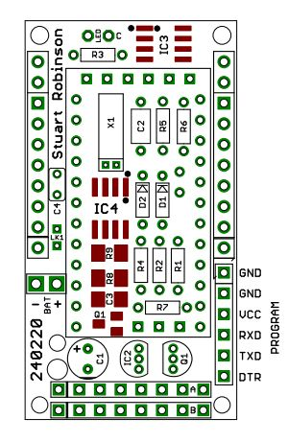

D1 - IN4148
This is a silicon diode that allows one of the ATmega328P interrupts (pin 2) to be shared between two devices, an external switch (for waking the board from sleep say) and the real time clock option described later. If your not using the real time clock option, then you don't need to fit D1 and can replace it with a wire link. If you want to use pin 2 to control an external device, turn something on\off for example then also replace D1 with a wire link. The black band on the glass encased diode should be at the end nearest X1,C3,R5,R6, see the layout above and picture below;
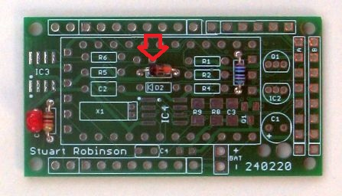

R7 – 22K
This resistor allows the ATmega328P to read a voltage level on a pin that exceeds the VCC of the processor which is 3.3V. With this resistor you can read the servo pulse from a 5V radio control receiver. Make sure that no more than 1mA can flow through the resistor. Note that pin 2 is located on both CONA and CONB. Where pin 2 is located on CONA, the pins are arranged so that the board can be plugged into and powered from a standard 3 pin 5V radio control servo connection, with the servo pulse connected to and read on pin 2. See the comments above for D1 and choose what you want to use pin 2 for. Note that if you do this 5V power from the radio control device is connected to the RAW pin on the Pro Mini, so be sure you don't have an external battery plugged in at the same time.

R5, R6 – 4K7
These are pull ups for the I2C devices. If you not going to connect any external I2C devices than you could omit these resistors. Also note that some external sensor boards have their own I2C pull ups, so they may be no need for fitting these 2 resistors. No harm will come if you do fit them however.

R1 – 12k, R2 – 100K, Q1 – 2N7000

Note: Boards shipped after 20th May 2021 will have R1 as 12K, R2 as 100K

These components form a resistor divider that is used to read the voltage on the Pro Minis RAW pin, i.e. the external battery. Power saving is achieved by using Q1 to turn the resistor divider on\off. If the small amount of extra battery current is not a concern, you can replace Q1 with a wire link between drain and source. On the PCB the gate of Q1 is the centre pin. You can read the voltage on the divider circuit on Arduino pin A0, when pin 8 (also used by the LED) is driven high. If you have no need to read the board supply voltage then you don't need to fit these components.

R3 – 1K, LED – Red
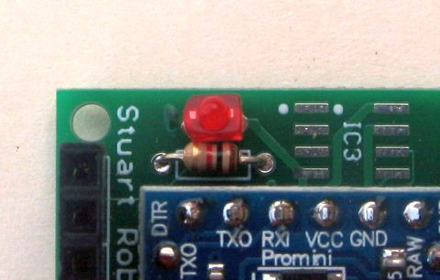
Useful as an indicator, fitting is not compulsory however. The LED has a flat side and a curved side. The LED is fitted with the Flat side of the LED nearest to the board position for IC3, see picture.

C2 – 100nF
This is an axial ceramic capacitor for extra decoupling. Fit if you wish, but the Pro Mini should work without it.

R4 – 4K7
There is a location for a DS18B20 temperature sensor on the PCB which can be fitted after the board is assembled. If you want to add DS18B20 later then fit this resistor now. Note: If you are using the power switching option (see bleow) you wont be able to fit and use the temperature sensor DS18B20 as IC2 and R4 should not be fitted.

4. Board options

C3 – 4u7, R8 – 47K, R9 – 22K, Q2 – IRLML6402
The board has the option of fitting some SMT components (C3, R8, R9, Q2) which are supplied wit the kit and provides the option of turning off the power to an external device, such as a GPS. It was not practical to use non-SMT components here due to the size constraints of the board. Q2 is an IRLML6402 P Channel MOSFET and was the best power switching device found. Its in a SMT SOT package, and if you can solder that in place, you will be able to add the other SMT components, C3, R8 and R9. These 3 components act to reduce the switch on spike that can occur when switching a device such as a GPS. The spike on the voltage supply can cause the processor to reset.

The default for the PCB is to have power to the external connector (CONB pin 1) permanently connected via link LK1 which is on the bottom side of the board. If you want to use the power switching components you will need to cut LK1 with a sharp knife blade, see the cut link below, highlighted in red.
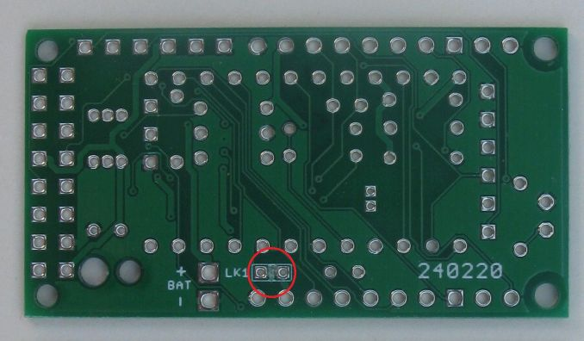

Note: If you are using the power switching option you wont be able to fit and use the temperature sensor DS18B20 as IC2 and R4 should not be fitted.

If your not going to need the power switching, don't fit C3, R8, R9 and Q1, leave LK1 alone and carry on.

The parts for the rest of the extra board options below are not supplied with the kit, you need to supply them yourself. If you are going to fit any of these options the components need to be fitted before adding the Arduino Pro Mini.

IC4 – PCF8563, X1 – 32768hz crystal, C4 – 15pF, D2 – IN4148 (parts not supplied)
If you want to use the real time clock alarm option to wake up the board, then fit these components.

C1 – 47uF (part not supplied)
This can add extra decoupling to the VCC supply rail for the processor if you feel that provided on your Pro Mini is not adequate.

IC3 – MB85RC16PNF or FM24CL64 FRAM (part not supplied)
Some of the SX12xx library examples use a FRAM for backup data storage. The FRAM can allow for the GPS location information to be stored on a very regular basis. If the board power is lost the information in the FRAM will be saved.

5. Base board build part 2

Arduino Pro Mini (part not supplied)
If you have got this far, you should have all the components you need fitted and can now add the Arduino Pro Mini. Note that once the Pro Mini is fitted you will be unable to add some of the components described above, which is why its necessary to read through all the instructions before soldering the Pro Mini in place.

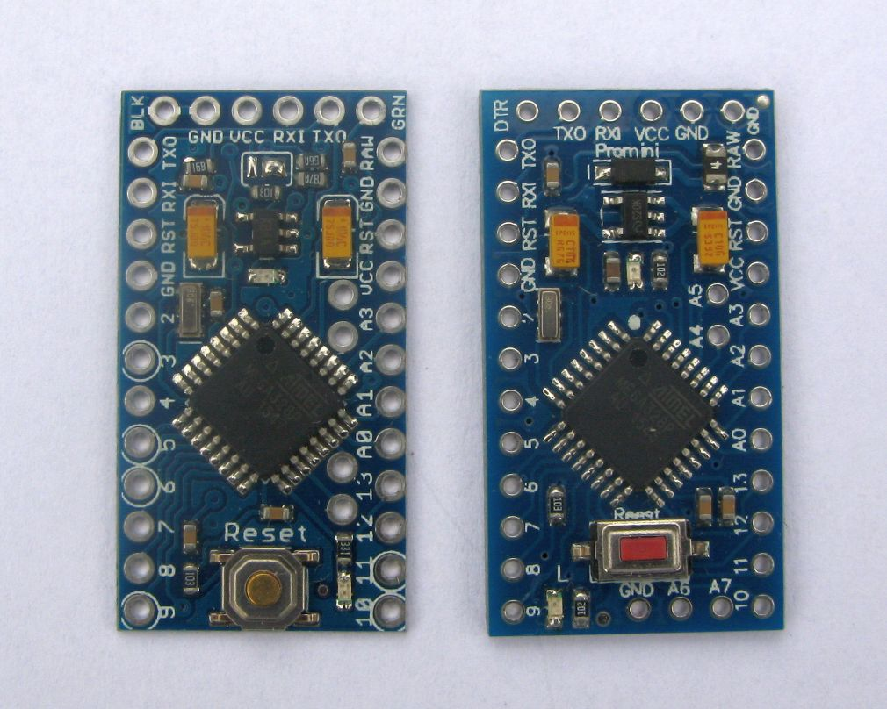

First make sure you have the right layout of Arduino Pro Mini and be sure its a 3.3V 8Mhz version. There are currently two common layouts of Pro Minis to be found on sites such as eBay. The one on the left in the picture above used to be the most common, but today the one on the right is seen most often. Its the one on the right that is needed, it has a fuse and reverse protection diode fitted, so this saves considerable space as these do not need to be added externally. Note the order of the programming pins on the top of this Pro Mini, left to right, DTR, TXD, RXD, VCC, GND. If this is not the order on your Pro Mini, it wont work with the Easy Pro Mini board. Also note that with this Pro Mini, A6 and A7 pins are on the bottom of the board next to pin 10.

Check that your Pro Mini actually is an ATMega328P, its not unknown for some sellers to use ATMega128P devices on their ‘Pro Minis’.

If you have the equipment, you can replace the bootloader on the Pro Mini with one that supports the Watchdog on the Atmel Processor correctly. On some Pro Minis the bootloader provided will not allow the Watchdog on the Atmel processor to operate correctly. To program my own Pro Minis I use the ‘Mini Core’ package for the Arduino IDE;

https://github.com/MCUdude/MiniCore

The bootloader with that package works correctly with the Watchdog and you can then use it as crash protection in your programs. I built a clip on programming lead for my Pololu ISP programmer which makes it easy to reprogram the bootloader on the Pro Minis. When programming the bootloader I also set the option to have the BOD (Brown Out Detector) at 1.8V. A lot of 3.3V Pro Minis have the BOD set at 2.7V which can cause the board to reset when batteries are low.
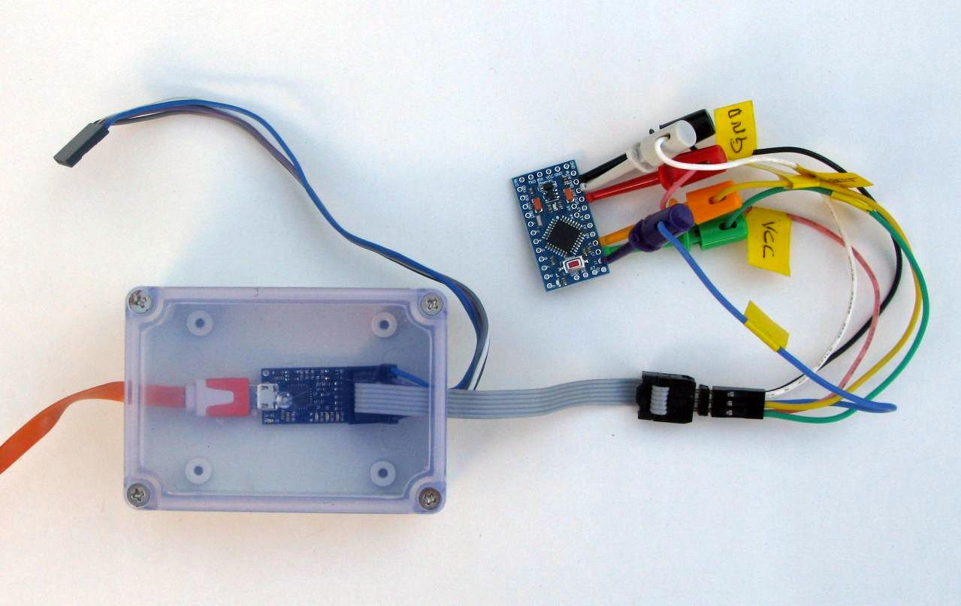

There are numerous tutorials to be found on the Internet that show you how to use an Arduino UNO as an ISP programmer.

Place the 0.1” pin headers in the board ready to fit the Pro Mini. There are 2 x 12 way on the long sides of the board and 1 x 6way on the end nearest the LED. There are also two 2 way headers to be fitted both are highlighted in red on the picture below. These are the A4,A5,A6 and A7 connections to the Pro Mini.
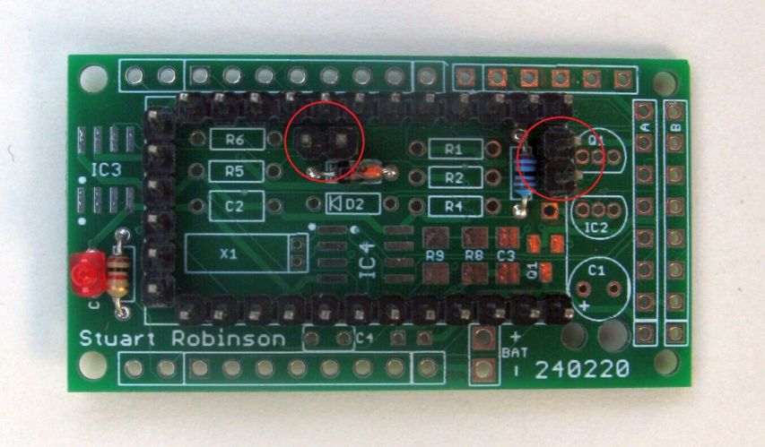

Place the Pro Mini on the headers pins and hold in place with an elastic band. Solder the pins in the corners, on the Pro Mini on top and also the pins on the bottom of the PCB. You can cut all the pins short now, and then solder them all in place. Cutting the pins before soldering gives a neater finish.

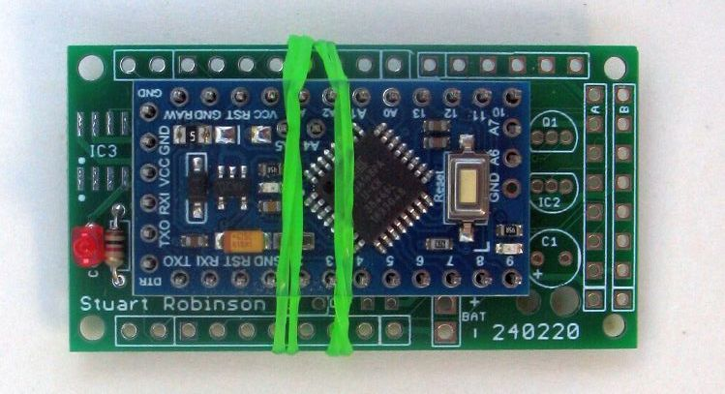

Next solder the 5 way 0.1” header for the program connector in place. There are 6 holes here to match the layout of the program header on the Pro Mini, but only 5 are needed, so its easier to fit the 5 way header, missing out pin 1 (outlined as a white square on the PCB). If you fit a 6 way header you may end up needing to file the bottom corner from any StuartsProjects modules you use. The GND connection for the program header is on the left in the picture below.
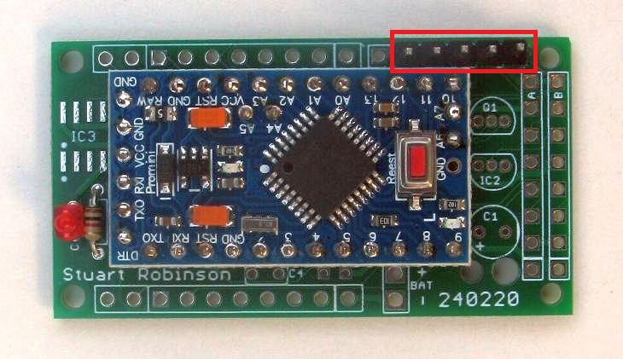

A standard 3.3V USB serial adapter can now be connected to the program header and will normally supply enough power to run simple test programs. Check that your USB serial adapter is set to 3.3V output.

Load the “1_LED_Blink” example program from the SX12XX library, check that the Arduino IDE is set for an 8Mhz Pro Mini or ATmega328P if using the mini-core and upload the program. Check that the LED flashes at once per second.

Expansion connector – CONA and CONB
Fit the supplied 2 row 8 way angled connector at the end of the board marked A and B.
You can now check that the board runs on an external battery, say 3 x AA Alkaline or a single Lithium battery, by connecting power to the pins on the expansion connector, CONA pins 1 and 2.

Battery lead
You can add the supplied silicone JST lead now, if you need it, it’s useful for connecting external batteries.. Put the black lead into the hole marked ‘–‘ on the PCB and the red wire into the hole marked ‘+’ on the PCB. Hold the wires in place and fit the zip tie to act as a strain relief on the battery lead. Yes the zip tie is a tight fit in the hole. Check that the LED blink program still runs when used with an external battery. I would suggest a battery of no higher voltage than 4 x AA Alkaline or NiMh batteries.

IC2 – DS18B20
The board does work with a DS18B20 temperature sensor fitted, but does require sole access to pin 4. Thus the DS18B20 will not work if you have fitted the power switching option since this also uses pin 4.

6. Improved deep sleep current
With the ATmega on the typical Pro Mini suggested into deep sleep mode the current consumption was measured at 50uA or so. There is little that can be done to reduce this, its a limitation of the components on low cost Pro Minis.
There is a PCB in development the same size and layout as the Easy Pro Mini but which uses the 28 pin DIP version of the ATmega328P. The regulator used is one with a quiescent current of around 2uA. This board is harder to build, but can take the same breadboard friendly lora modules and has a deep sleep current of 2.5uA.
Have fun.

Stuart Robinson

May 2021

